**23CSE111**

**OBJECT ORIENTED PROGRAMMING**

**LAB REPORT**



**Department of Computer Science Engineering**

**Amrita School of Computing**

**Amrita Vishwa Vidyapeetham, Amaravati Campus**

**Name: KASI HARINI**

**Verified By Roll No: AV.SC.U4CSE24203**

WEEK 01

PROGRAM-1:

AIM: Download and Install Java Software

PROCEDURE:

Step 1: Download JDK 21

1. Open your web browser and go to the Oracle JDK Downloads page
2. Scroll down to the Java SE Development Kit 21 section.
3. Choose the Windows x64 Installer version.
4. Click on Download, then Wait for the download to complete.

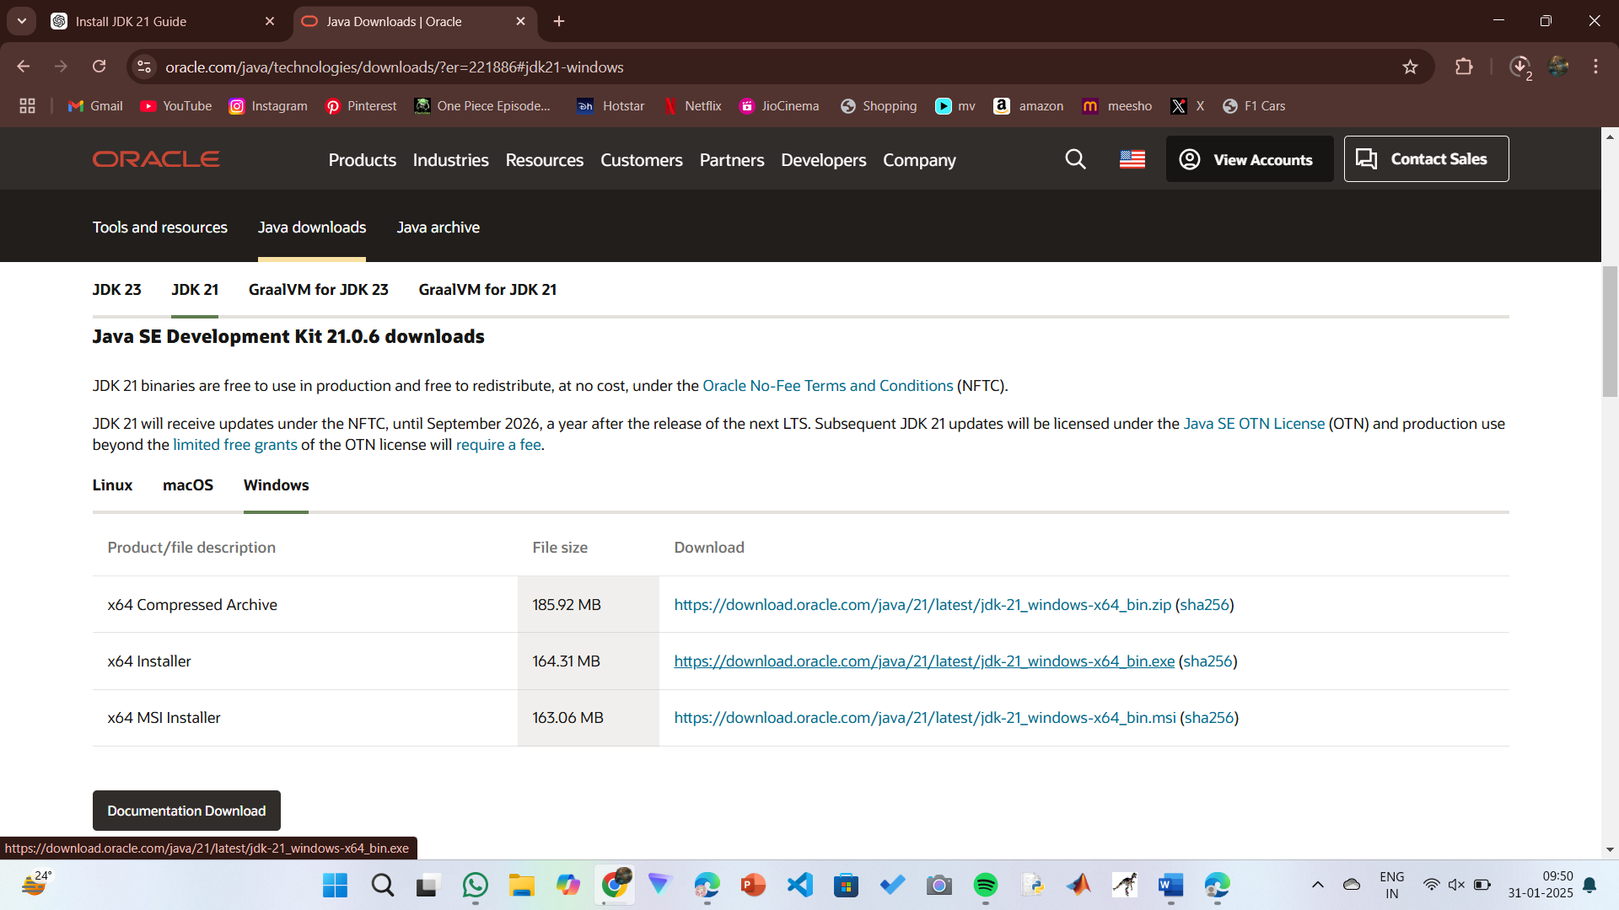

Step 2: Install JDK 21

1. Locate the downloaded jdk-21_windows-x64_bin.exe file.
2. Double-click to launch the installer.
3. Click Next on the setup wizard.
4. Choose the installation path (default is C:\Program Files\Java\jdk-21).
5. Click Next, then click Install.
6. Wait for the installation to complete.
7. Click Close once the installation is finished.

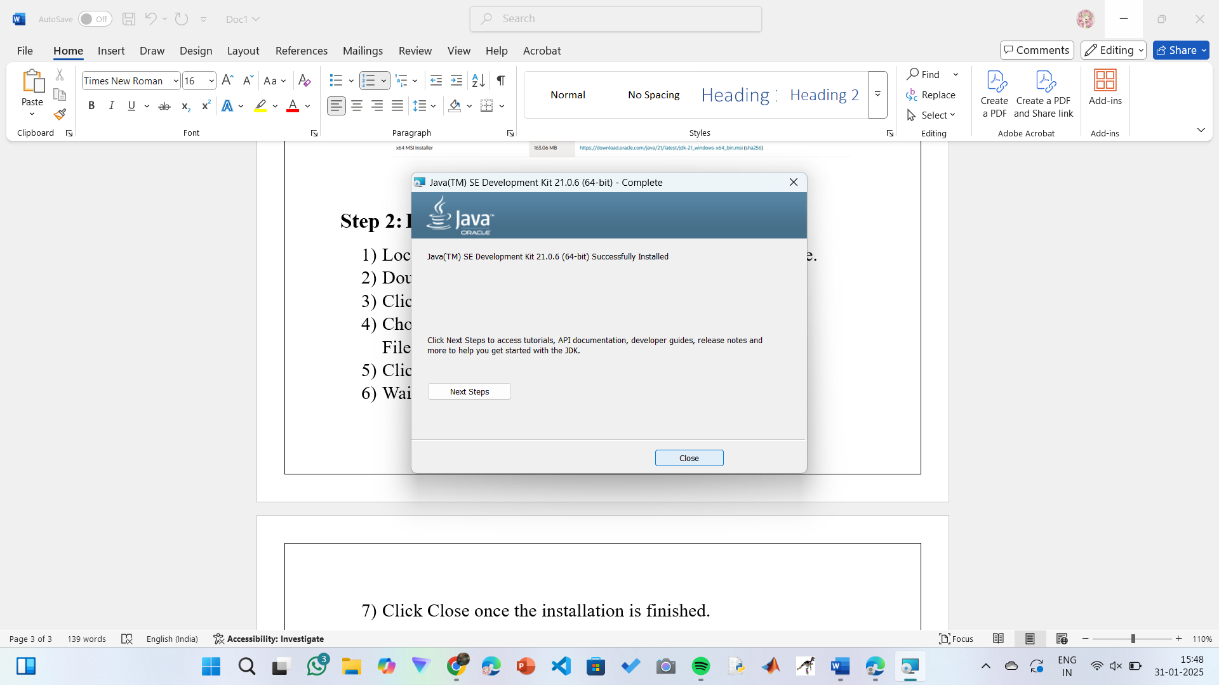

Step 3: Setting up the path

1) Go to “Windows C” Drive on Desktop

2) Choose Program Files, select Java, then JDK 21, then select Bin.

3) Select and copy the path at the address bar.

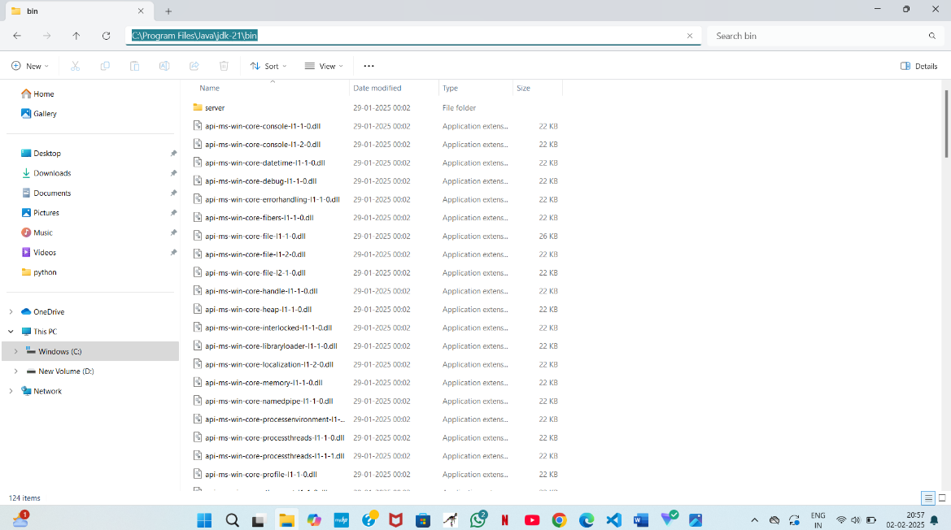

Step 4: Open System Properties

1. Press Windows + R, type sysdm.cpl , and click Ok-
2. The System Properties window will open.
3. Navigate to the Advanced tab.
4. Click on Environment Variables at the bottom.

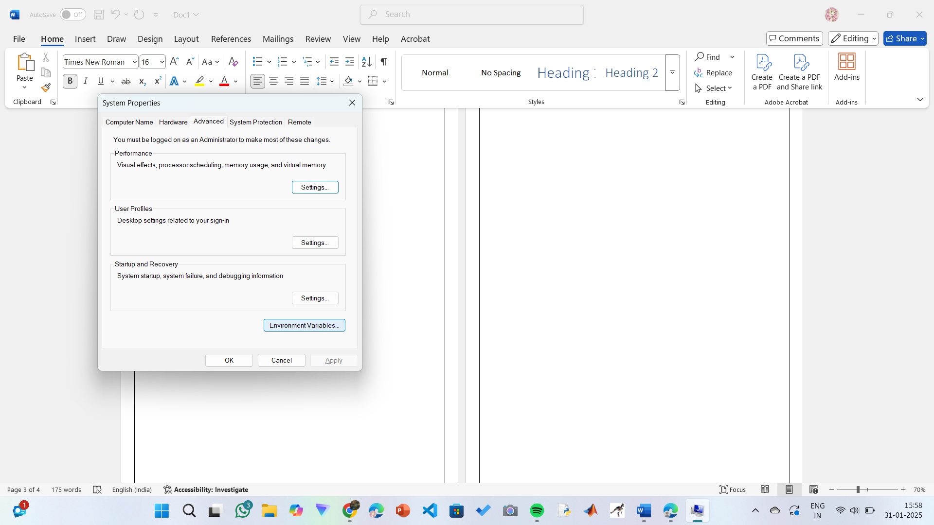

Step 5: Set JAVA_HOME

1) Under System Variables, click New.

2) Set the Variable name as JAVA_HOME.

3) Set Variable value as C:\Program Files\Java\jdk-21 (or your installation path).

4) Click OK.

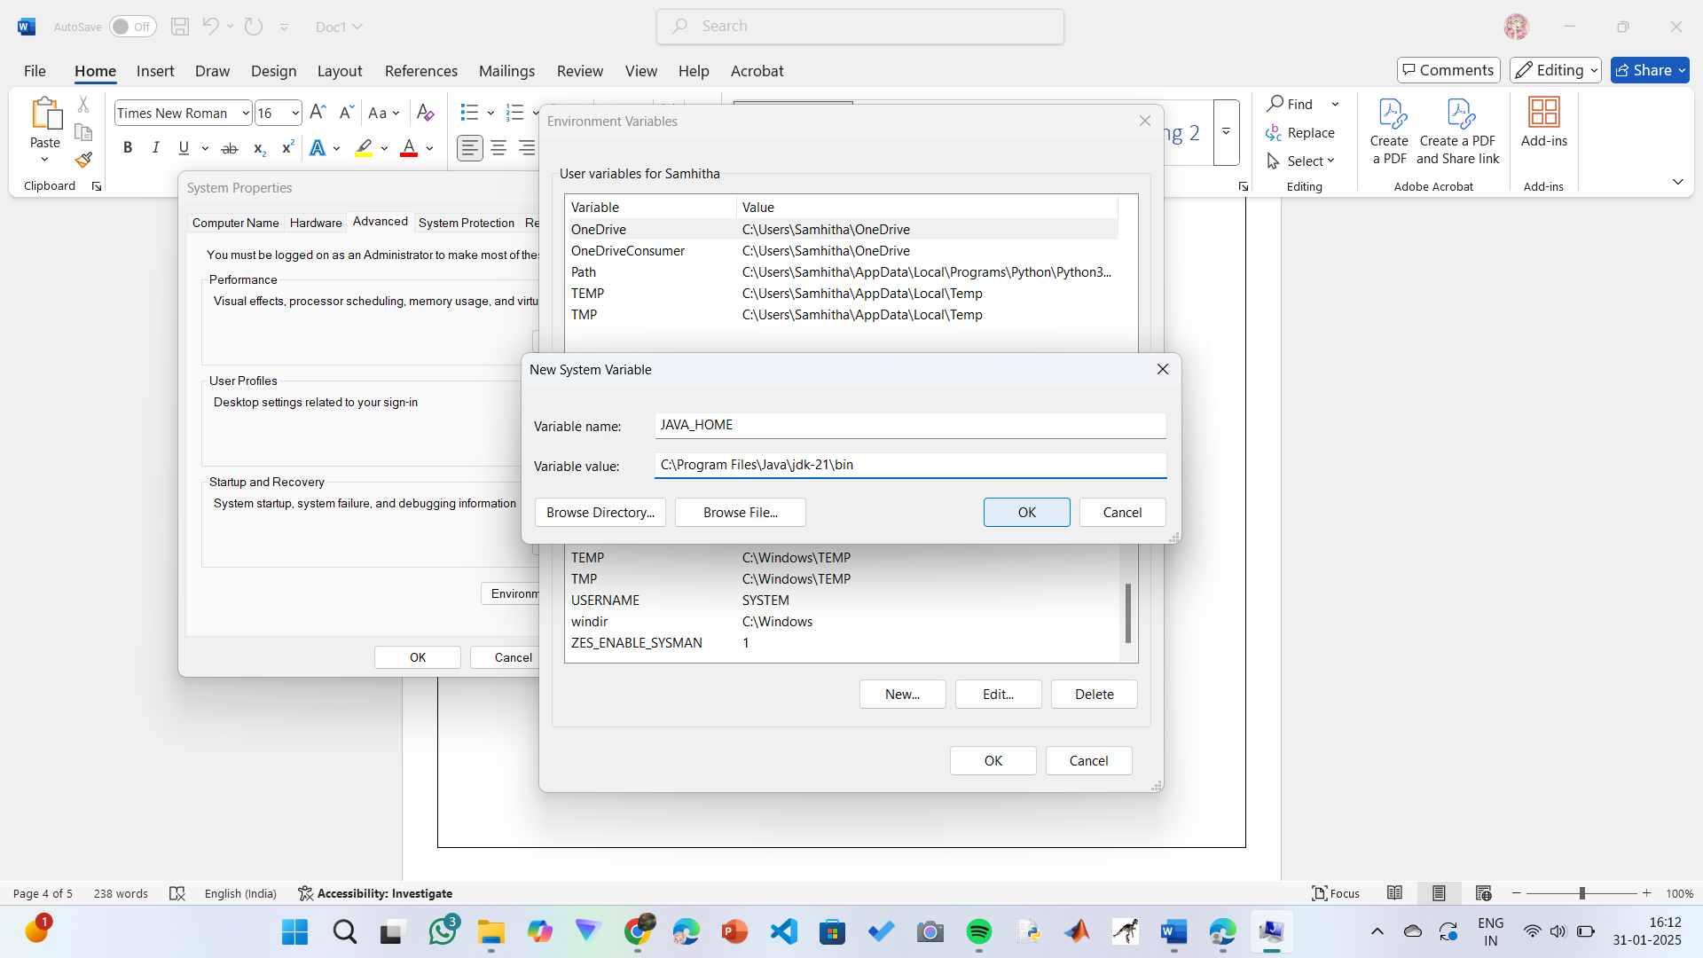

Step 6: Update PATH Variable

1) In System Variables, find Path and click Edit.

2) Click New and add: C:\Program Files\Java\jdk-21\bin

3) Click OK to save.

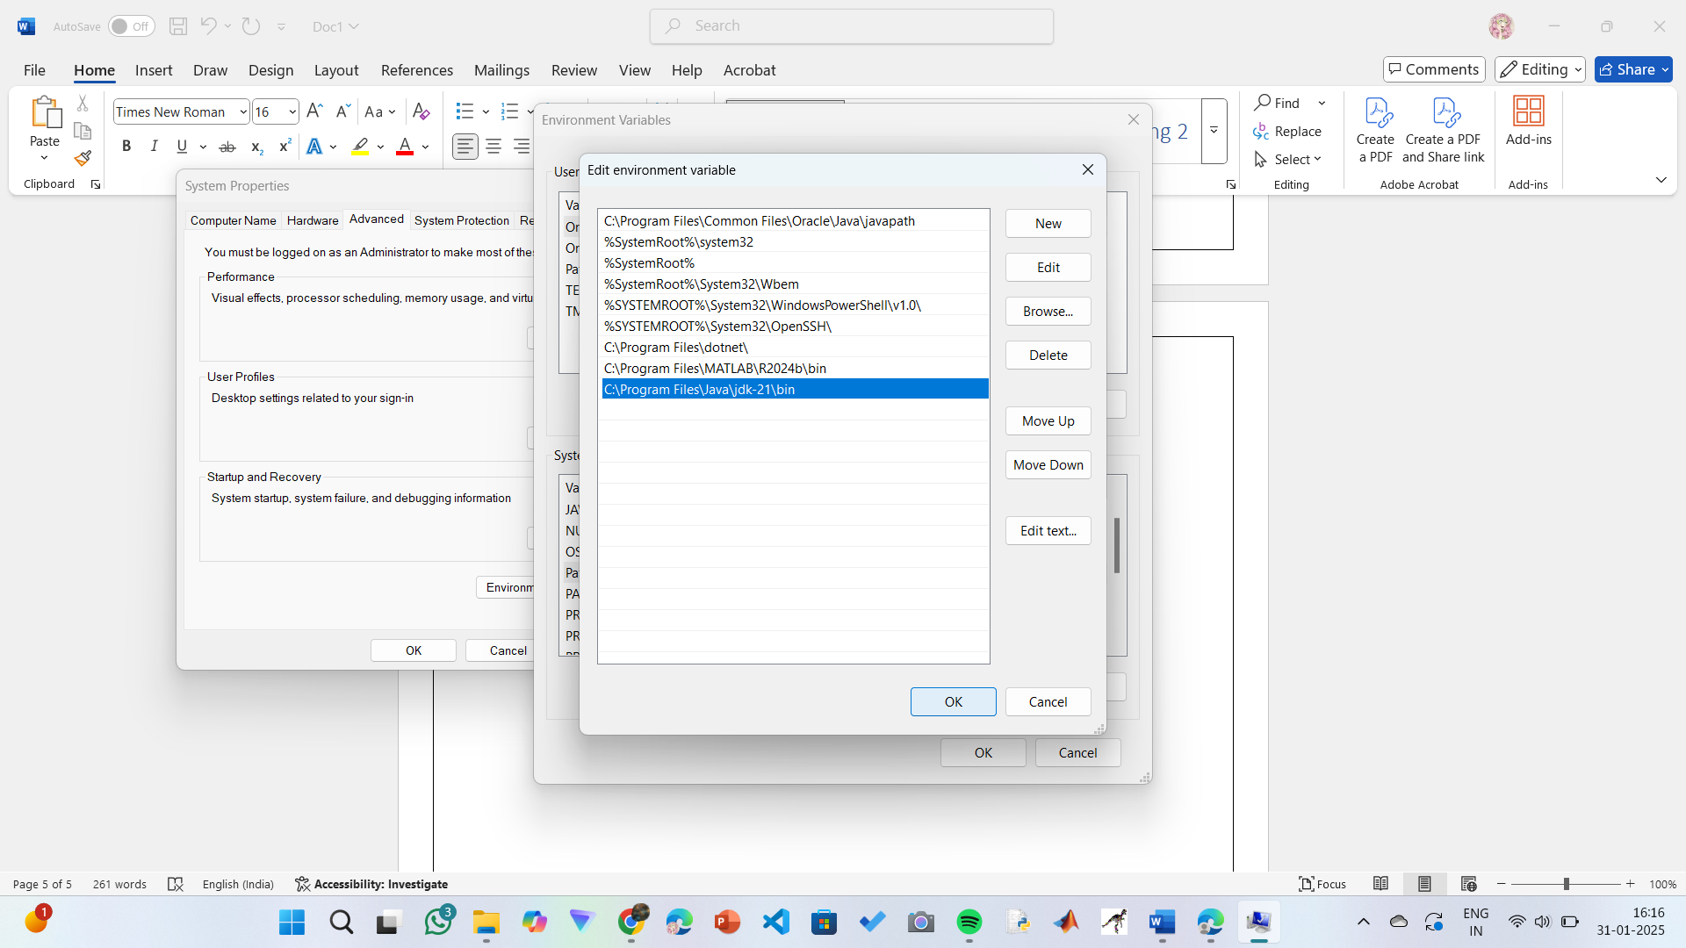

Step 7:Verify Installation

1. Open Command Prompt.
2. Type the following command: java --version and press Enter.

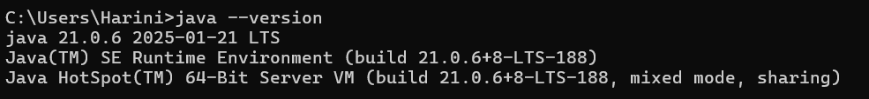

1. To check the java compiler type: **javac –version.**



PROGRAM-2:

AIM: Write a Java program to print the message “Welcome to Java Programming.”

CODE:

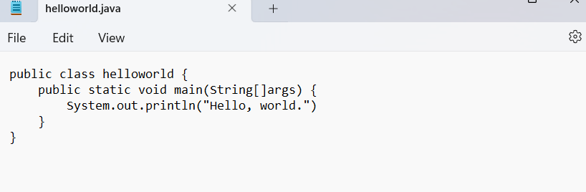

**Output:**

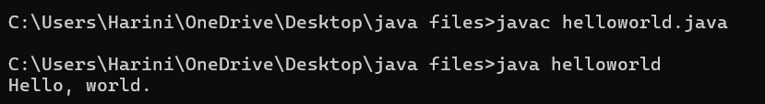

**ERRORS:** None found

**PROGRAM-3:**

**AIM:** Write a Java Program that prints Name, Roll No, Section of a student.

**CODE:**

**STUDENT DETAILS:**

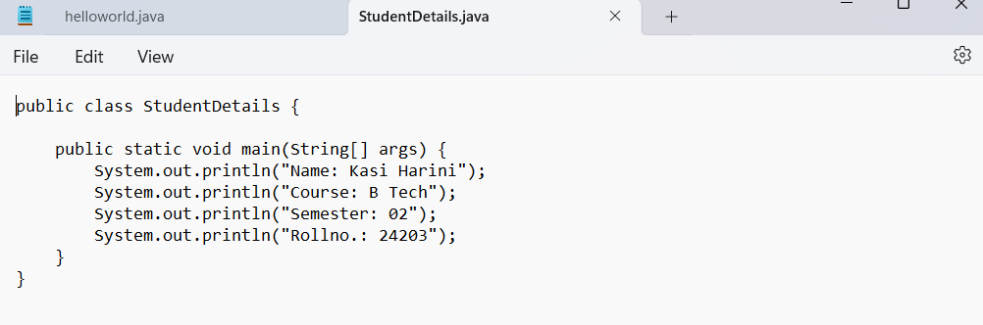

**OUTPUT:**

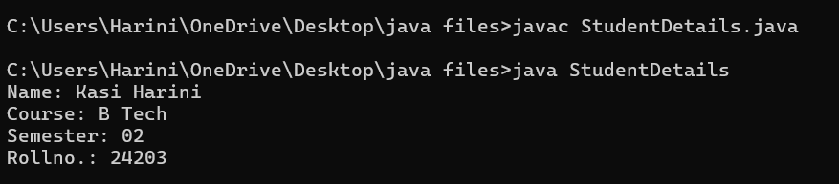

ERROR TABLE:

|  |  |
| --- | --- |
| **Code Error** | **Code rectification** |
| 1. writing small “S” in place of ”S”   In system.out.println()  2)not giving strings to the name and section | 1. code is rectified by keeping capital “S” 2. Giving strings to name and section |

WEEK – 2:

PROGRAM-1:

AIM: Write a java program to find the simple interest where all the inputs are taken from the user.

CODE:

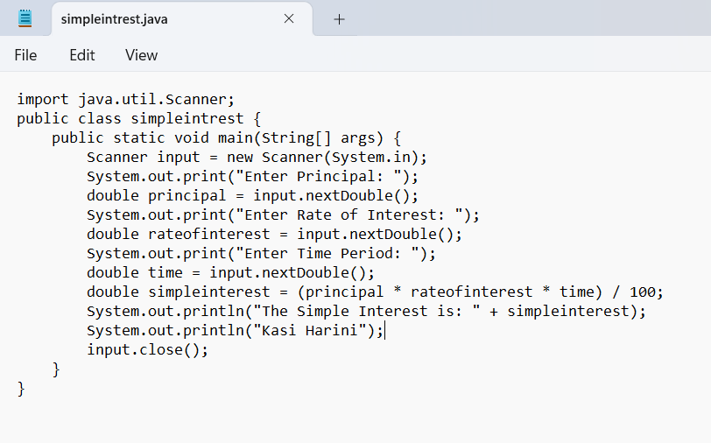

OUTPUT:

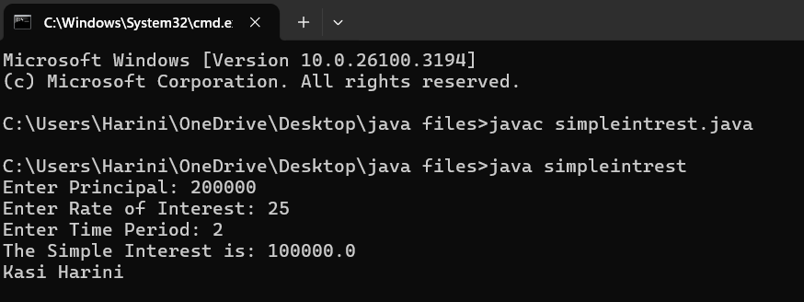

ERROR TABLE:

|  |  |
| --- | --- |
| **Code Error** | **Code rectification** |
| 1. Giving space between next and Double. 2. Not giving parenthesis after closing the input. | 1. Should not give space between next and Double. 2. We must put parenthesis after closing the input. |

PROGRAM-2:

AIM: Write a java program to find the factorial of a number where all the inputs are taken from a user.

CODE:

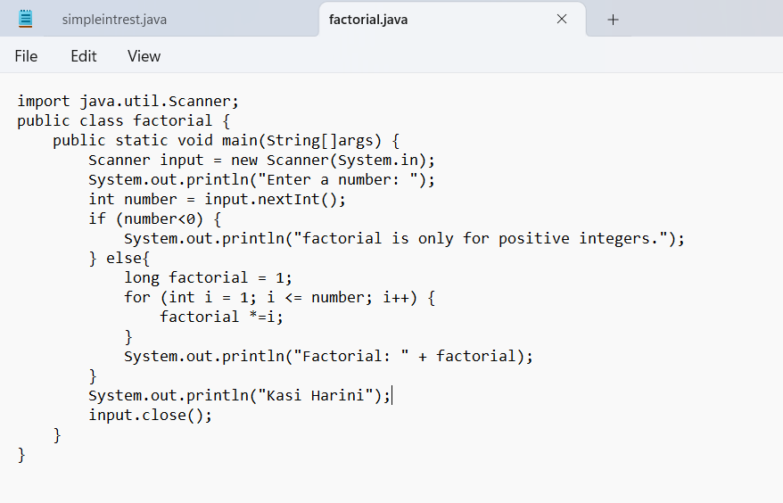

OUTPUT:

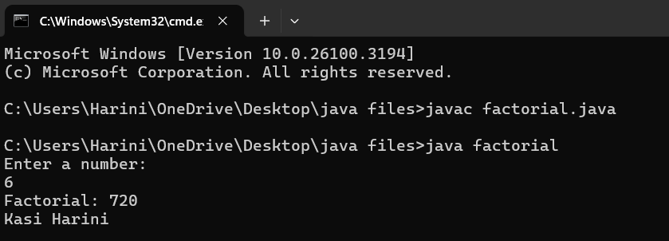

ERROR TABLE:

|  |  |
| --- | --- |
| **Code Error** | **Code rectification** |
| 1. While using for iteration, not giving the conditions correctly. 2. Declaring the data type as double instead of int. | 1. We should give iterative statements correctly. 2. We should give the data type as int for integers. |

PROGRAM-3:

AIM: Write a java program to convert the temperature from Celsius to Fahrenheit and Celsius to Fahrenheit.

CODE:

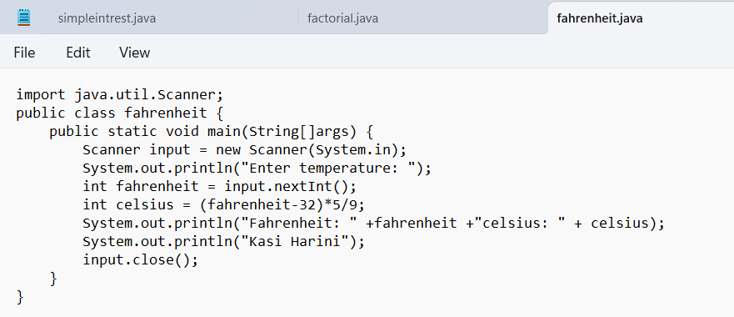

OUTPUT:

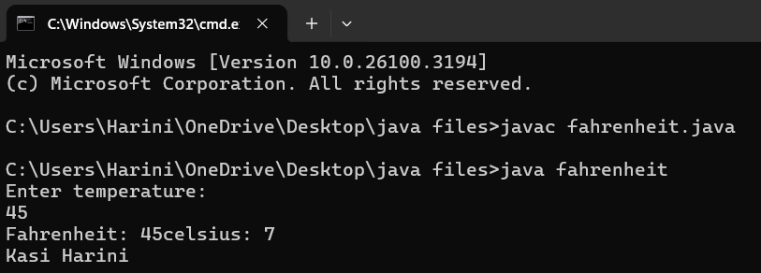

CODE:

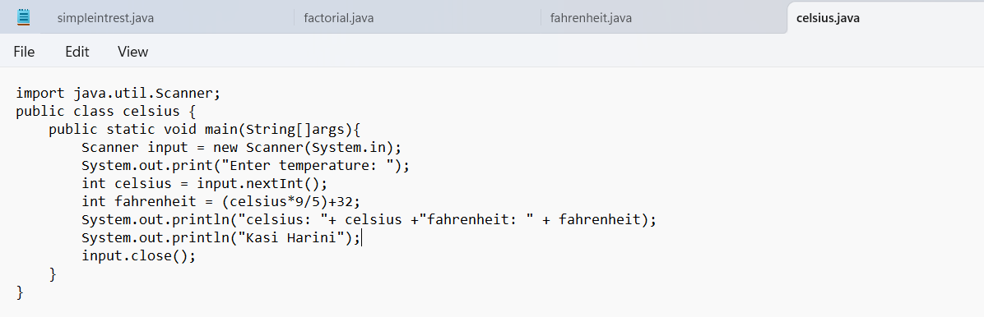

OUTPUT:

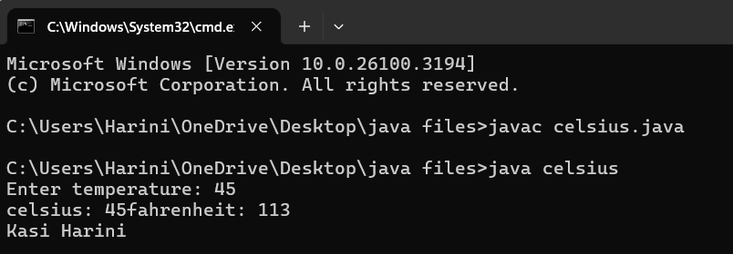

ERROR TABLE:

|  |  |
| --- | --- |
| **Code Error** | **Code rectification** |
| 1. While printing the variable not giving + sign. 2. Not closing the scanner. | 1. We should give correct indentation. 2. Closing the scanner is must. |

PROGRAM – 4:

AIM: Write a java program to find the Fibonacci series of a given number where all the inputs are taken from the user.

CODE:

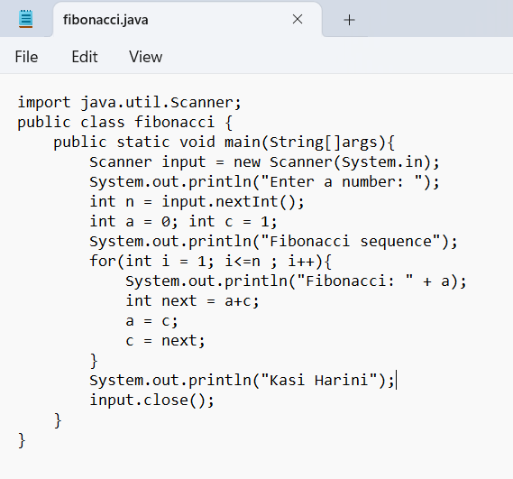

OUTPUT:

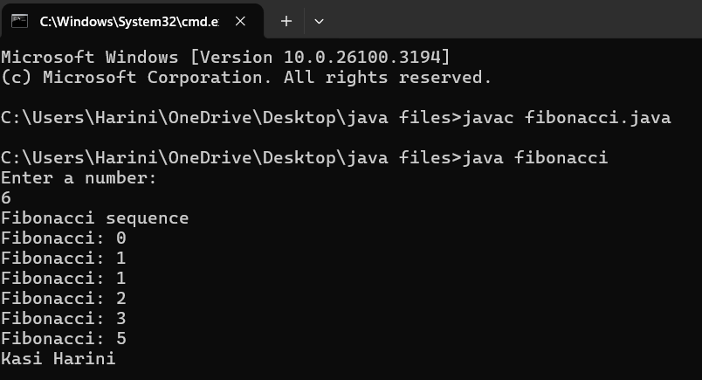

ERROR TABLE:

|  |  |
| --- | --- |
| **Code Error** | **Code rectification** |
| 1. Giving space between next and Double. 2. Not giving parenthesis after closing the input. | 1. Should not give space between next and Double. 2. We must put parenthesis after closing the input. |

PROGRAM-5:

AIM: Write a java program to find the Area of a rectangle, where all the inputs are taken from the user.

CODE:

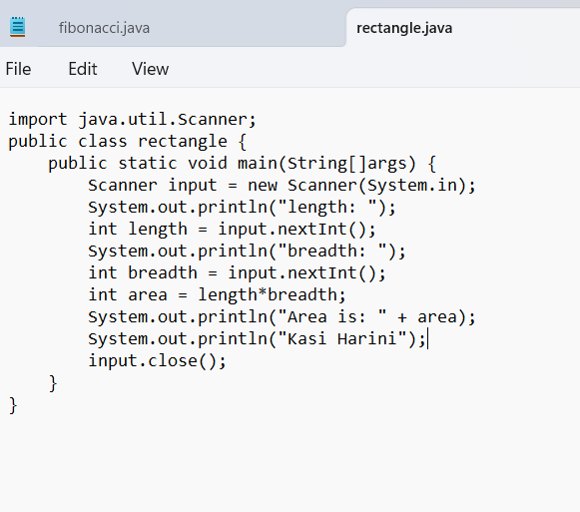

OUTPUT:

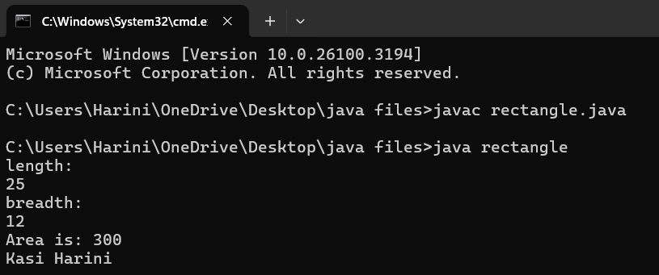

ERROR TABLE:

|  |  |
| --- | --- |
| **Code Error** | **Code rectification** |
| 1. While using for iteration, not giving the conditions correctly. 2. Declaring the data type as double instead of int. | 1. We should give iterative statements correctly. 2. We should give the data type as int for integers. |

PROGRAM – 6

AIM: Write a java program to find the Area of a Triangle using heron’s formula, where all the inputs are taken from the user.

CODE:

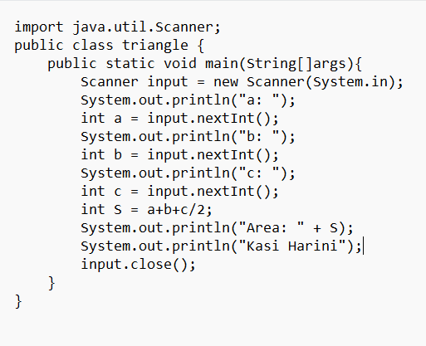

OUTPUT:

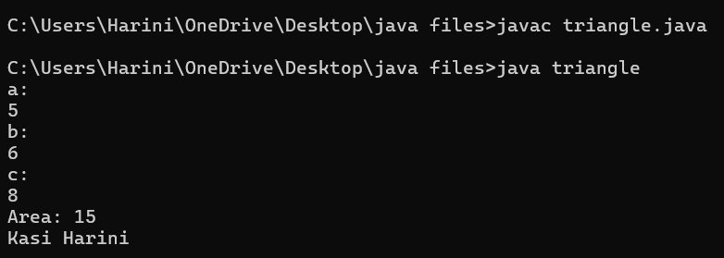

ERROR TABLE:

|  |  |
| --- | --- |
| **Code Error** | **Code rectification** |
| 1. While printing the variable not giving + sign. 2. Not closing the scanner. | 1. We should give correct indentation. 2. Closing the scanner is must. |